**Name: Roll no:**

**Experiment No: 1 Date:**

**VERIFICATION OF OHM’S LAW**

**Aim**

To verify Ohm’s law in DC circuit.

**Components/Equipment Required**

|  |  |  |  |
| --- | --- | --- | --- |
| Sl. No. | Components/ Equipment | Range | Quantity |
| 1 | DC Power Supply | 0-30V | 1 |
| 2 | DMM as Voltmeter | 0-30V | 1 |
| 3 | Bread board |  | 1 |
| 4 | Resistor | 1 kΩ, 2.2 kΩ | 1 each |
| 5 | DMM as Ammeter | 0 - 20mA | 1 |

**Theory**

The fundamental relationship among the three important electrical quantities current, voltage, and resistance was discovered by Georg Simon Ohm. One statement of Ohm’s law is that the current through a resistor is proportional to the voltage across the resistor. In this experiment you will see how Ohm’s law is applicable to a simple circuit using two resistors connected in series and then in parallel. Ohm's law states that if the temperature and other physical conditions of a metallic conductor are unchanged, the ratio of the potential difference across the conductor (V) to the current (I) is a constant. This constant ratio (R) is the resistance of the conductor.

According to Ohm's law, the voltage across a resistor is proportional to the current passing through it:

V = I R

The unit of resistance is ohm, which is equal to one volt per ampere. For common conductors such as metals, the resistance is a constant if the temperature does not change significantly. At certain temperature, the resistance of a resistor depends on its geometric parameters (the length and the cross-sectional area), its physical property (resistivity):

R = ρL/Α

where ρ, L and A are, respectively, the resistivity, the length and the cross-sectional area of the resistor.

**Precautions:**

1. Please be careful about the modes of multi-meter. When you measure a voltage, you are not allowed to use current mode (A), and vice versa. Otherwise, the fuse in the multi-meter will be burned.
2. Ensure that the voltage controller knob of power supply is kept at minimum position before starting the experiment and after taking the readings.
3. Ensure that the power dissipation in resistors not exceeding the rated values (mostly 0.25W).

# Procedure:

1. Connections are made as per the circuit diagram.
2. Check your connections before switch on the supply.
3. Vary the regulated supply up to 30 V.
4. Measure the voltage using voltmeter and current using ammeter.
5. Note the readings in the tabulation.
6. Plot a graph with V along x-axis and I along y-axis.
7. The graph will be a straight line which verifies Ohm's law.

# Circuit Diagram

# a) Resistors in series

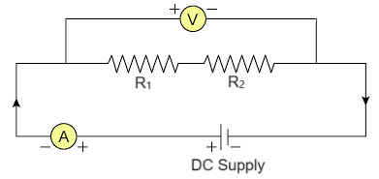

**b) Resistors in parallel**

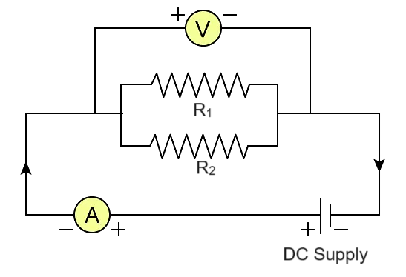

**Tabular Column**

1. **Resistors in series**

Equivalent resistance = …………………. kΩ

|  |  |  |  |
| --- | --- | --- | --- |
| **Sl No:** | **Voltage (V)** | **Current (mA)**  **(Theoretical)** | **Current (mA)**  **(Practical)** |
| 1 |  |  |  |
| 2 |  |  |  |
| 3 |  |  |  |
| 4 |  |  |  |
| 5 |  |  |  |
| 6 |  |  |  |

**b) Resistors in parallel**

Equivalent resistance = …………………. kΩ

|  |  |  |  |
| --- | --- | --- | --- |
| **Sl No:** | **Voltage (V)** | **Current (mA)**  **(Theoretical)** | **Current (mA)**  **(Practical)** |
| 1 |  |  |  |
| 2 |  |  |  |
| 3 |  |  |  |
| 4 |  |  |  |
| 5 |  |  |  |
| 6 |  |  |  |

**Voltage vs. Current graph**

**a) Resistors in series**

**b) Resistors in parallel**

**Results and Inferences:**

|  |  |
| --- | --- |
| Observations and Results  (5 Marks) |  |
| Timeliness of submission  (5 Marks) |  |
| Total (10 Marks) |  |

Signature of the faculty member